Terracotta Upgrade Testing:

We started our Terracotta upgrade testing with version TC4.0.5. During the initial test in DEV we ran across several issue in which "Too many open files" and "TMC"(Terracotta Management Console) were the major. The issue got resolved when the machine's "ulimit size" was increased from "1024" to "131072". But during the PERF run, though the test run went fine, the Ehcache server got disconnected when TMC(Terracotta Management Console) was brought up after the RUN.

Data's Provided to Terracotta Team after the run:

1]Forceful Heap Dump

2]Server logs

3]Client logs

4]open files count recorded during the run.

TC team suggestions for TC 4.2 versions:

After the analysis, TC team came up asking us to proceed the testing with 4.2 version. TC4.2 had many configuration changes compared to 4.05 version in which separate port to TMC was a major enhancement compared to its previous  versions.

In TC4.2 we faced the duplicate instance getting connected to Quartz servers and when the issue was reported to Terracotta Team, they claimed that 4.2 has got lot of enhancements than 3.6.4 and again they suggested us to go for 4.1.5 or 4.0.7 as these versions are used by their clients widely.

TC4.1.5 Testing:

Then we tested with TC4.1.5 version in Development environment. Even in TC4.1.5 the duplicate instance connectivity issue existed and the information showed in TMC had few abnormalities in the console. The Weblogic/Terracotta clients were connected twice with Quartz servers. Upon discussion with TC team, we went for functionality testing of the application to nail down if it is a monitoring level issue.

Application functionalities focused and Validated during the test:

1]Ehcahe - Off heap storage - storage in heap

2]Quartz - Persistence storage - storage in disk

3]Active-Passive Failover

4]Basic application functionalities

5]Batch Job Scheduling

6]TMC connectivity

There were no issues reported during the functionality testing by DEV team and it was reported that the jobs were running successfully.

But during the test "Ehcache - Off heap storage" and "Quartz - Persistence storage" mechanism was not working as expected and TMC was not able to collect the instance connected to TSA(Terracotta Server Array).

Cache Storage Issue:

On Analysing, we could see storage configuration parameters used in TC4.0.5 has been deprecated and new parameters were added in TC4.1.x. On changing the below parameters, we were able to store the cache in Ehcache-Heap and Quartz-disc.

In TC3.6.4,

**<offheap>**  
**<enabled>true</enabled>**  
**<maxDataSize>8g</maxDataSize>**  
**</offheap>**

Replacing in TC4.1.5 with,

**<dataStorage size="8g">**  
**<offheap size="8g"/>**  
**</dataStorage>**

TMC (Terracotta Management Console):

Inorder to troubleshoot it, we had 2 checkpoint calls with Terracotta support. There were few additional configuration changes that was required to be modified in TC4.1.x versions for "TMC" compared to TC4.0.5.

Disabling of JMX Authentication,

The below tags are removed from tc-config.xml for enabling TMC.

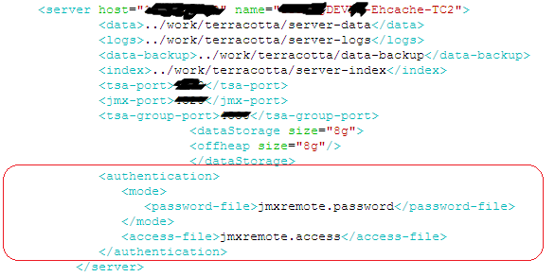

TMC basically uses the TSA port configured in the tc-config.xml file. But Terracotta claims that few functionalities of TMC still uses JMX port for collecting instance details. Here, since there is JMX authentication provided in our Ehcache and Quartz servers, TMC is unable to collect the instance details which gets failed in authentication level. In TC4.1.x the authentication for the servers is provided while logging into TMC and one who has Admin access will be able to clear the server cache's. Previously in TC3.6.4, there were no separate port for TMC and the cache's were cleared by Admin using JMX Authentication when needed. Now Terracotta uses a separate TSA port for authentication. So we should not be having any issue in disabling JMX port except monitoring in Macaw which we need to check further.

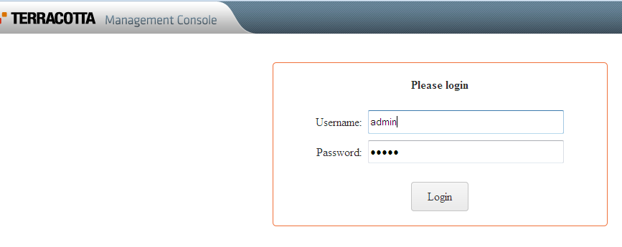

Once the JMX authentication was removed from the tc-config.xml, TMC was able to gather instance details of the servers running successfully.

After Upgrade:

We don't have any known issue except duplicate client connectivity with Quartz servers. Terracotta team cliams that it doesn't have any impact with the application functionality and its a monitoring quirk. They also says that its a known issue from their end and TMC is now solely for Ehcache monitoring and it is not yet evolved for Quartz monitoring completely. Terracotta Team recommends us to proceed with Performance Testing with the current configurations set.